Ideation Phase

Define the Problem Statements
Project Title | DarshanEase: A Smart Temple Darshan Booking System Using MERN Stack
Team ID | ALITS-CSD-2026-DarshanEase
Team Members | Salapala Tharun Kumar Reddy (Team Leader); A. Goutham; M. Siva Prasad; M. Akhila; K. Hemalatha
College | Anantha Lakshmi Institute of Technology and Sciences (ALITS)
Academic Year | 2026

Customer Problem Statement Template
A well-articulated problem statement grounds the DarshanEase solution in the real difficulties devotees and temple administrations face today.
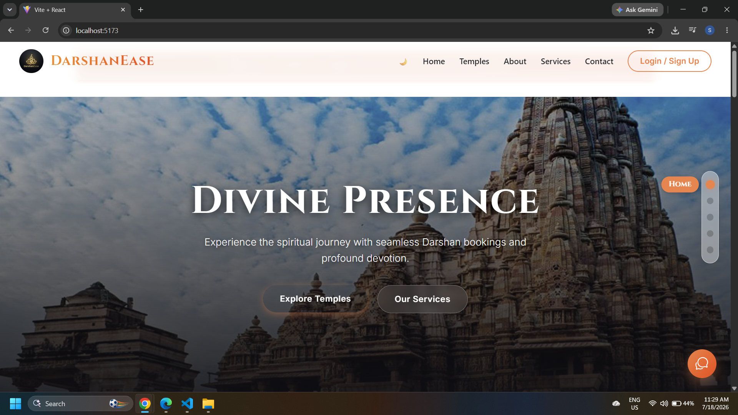
Figure: DarshanEase — the platform built to resolve the problem statements below

Problem Statements
PS | I am (Customer) | Trying to | But | Because | Which makes me feel
PS-1 | a working professional devotee planning a temple visit | book a darshan slot in advance so I don't waste my holiday standing in a queue | most temples only offer offline or phone-based booking | there is no single online platform showing live slot availability across temples | frustrated and anxious about wasting my limited travel time
PS-2 | an out-of-town pilgrim visiting an unfamiliar city | plan my bus, train, or flight along with my temple visit | I have to search multiple travel apps and temple websites separately | journey planning and darshan booking are not integrated into one system | overwhelmed and unsure whether my schedule will actually work out
PS-3 | an elderly or first-time visitor | understand temple timings, darshan types, and booking steps easily | temple information is scattered, outdated, or hard to find online | there is no centralized, mobile-friendly source of verified temple information | confused and dependent on others for basic travel decisions
PS-4 | a temple administrator | manage booking volumes and reduce overcrowding at the temple | manual registers and walk-in queues make it hard to forecast footfall | there is no digital admin dashboard to track and manage bookings in real time | stretched thin and unable to plan staffing or crowd control effectively

